A MAJOR PROJECT REPORT ON
AI Powered Customer Retention Prediction System
Submitted for Award of Internship Certified for
THE SKILL UNION
Under
VIHARA TECH
Submitted by
D. SUSHMITHA SREE
UNDER THE ESTEEMED GUIDANCE OF
Mr. K SAI KAMAL
Assistant Professor
(B. Tech - AI/ML Eng., Data Scientist, CV Eng.)

 | 

DATA SCIENCE
THE SKILL UNION | VIHARA TECH

THE SKILL UNION | VIHARA TECH
VT Plaza, C/14, 4th Floor, Road No:1, KPHB, Kukatpally, Hyderabad, Telangana – 500072

Certificate
This is to certify that the Project Work entitled “AI Powered Customer Retention Prediction System” is a Bonafide record of the Industry Oriented Major Project Work submitted by

D. SUSHMITHA SREE
Fulfillment of the requirements for the award of the Internship in The Skill Union under Vihara Tech during his/her course duration.

SIGNATURE OF VIHARA TECH  TRAINER  Mr. K Sai Kamal | SIGNATURE OF VIHARA TECH  MENTOR  Mr. Devaram Pranith

SIGNATURE OF THE SKILL UNION
CEO

Mr. K Sai Krishna
DECLARATION

I, D. Sushmitha Sree, hereby declare that this project report, titled " AI-Powered Customer Retention Prediction System ", is the result of my original work completed during the 6-month IT/Programming Language training course at Vihara Tech. This project was executed over the full term, incorporating the practical knowledge gained during the four months of intensive classroom training and the real-world experience acquired during the subsequent two-month paid internship at The Skill Union. The information and findings presented herein are a true and accurate reflection of the work performed and have not been submitted, in whole or in part, for any other degree or diploma. I confirm that all sources of information have been specifically acknowledged.

Name | Batch / Course | Signature
D. SUSHMITHA SREE | Data Science

ACKNOWLEDGEMENT

The successful completion of this project and the valuable experience gained throughout the six-month training program would not have been possible without the unwavering support and invaluable contributions of several individuals. I extend my deepest gratitude to all those who guided me and facilitated my learning journey.
My sincere appreciation goes to Mr. K Sai Kamal, Data Science & AI/ML Trainer, for their exemplary commitment to education. Their invaluable expertise and clarity in delivering complex programming concepts formed the crucial technical foundation upon which this entire project rests. The dedication they showed in making the classroom sessions truly illuminating has fundamentally shaped my approach to software development.
I am profoundly thankful to my dedicated Institute Mentor, Mr. Devaram Pranith. Their steadfast guidance during both the project development and the subsequent two-month internship was instrumental in bringing this report to fruition. Their insightful suggestions, technical foresight, and willingness to offer practical mentorship at critical junctures were truly inspiring and elevated the quality and direction of the work presented here.
Finally, I wish to acknowledge the visionary leadership of Mr. K Sai Krishna, CEO of The Skill Union. It is through their strategic stewardship that the Skill Union has created an outstanding environment, fostered a culture of excellence and provided career-defining opportunities like the one I have just completed. This initiative has been a powerful launchpad for my professional trajectory.
This project has been a significant milestone, and I am grateful for the collective efforts that made this comprehensive learning experience possible.

Table of Contents

S. No. | Chapter  No | Section Title | Page No.
1 |  | Cover Page | 1
2 |  | Certificate | 2
3 |  | Declaration | 3
4 |  | Acknowledgement | 4
5 |  | Table of contents | 5-7
6 |  | Architecture | 8
7 |  | Abstract | 9
8 |  | Introduction | 10
9 |  | Requirements of the model development | 11-12
10 | 1 | Data visualization | 13-22
11 | 1.1 | Visualization overview | 13
12 | 1.2 | Churn comparision | 13-14
13 | 1.3 | Dependents with churn | 15
14 | 1.4 | Tenure with churn | 15-16
15 | 1.5 | Multiple lines comparision | 16-17
16 | 1.6 | Monthly charges with gender and churn | 17-19
17 | 1.7 | Contract comparision | 19-20
18 | 1.8 | Paperless Bill comparision | 20-21
19 | 1.9 | Internet Service comparision | 21
20 | 1.10 | Final observations of the visualizations | 22
21 | 2 | Feature Engineering | 23-37
22 | 2.1 | Handling missing values | 23-27
23 | 2.2 | Data separation | 27
24 | 2.3 | Variable Transformation | 27-34
25 | 2.4 | Handling outliers | 34-37
26 | 3 | Feature Selection | 37
27 | 3.1 | Categorical encoding | 37-39
28 | 3.2 | Filter methods | 39-40
29 | 3.3 | Hypothesis testing | 40-41
30 | 4 | Merging | 41
31 | 5 | Data Balancing | 42-43
32 | 6 | Feature Scaling | 43
33 | 7 | Model Training | 44-45
34 | 8 | Hyperparameter Tuning | 45-46
35 | 9 | Best Model | 46-47
36 |  | Result | 47
37 |  | Conclusion | 48
38 |  | Future Enhancements | 48
39 |  | References | 49

Architecture
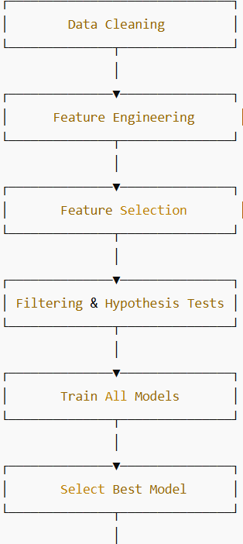
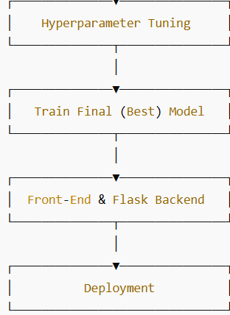

Abstract
Customer churn is a critical challenge in the telecom industry, directly impacting revenue, customer lifetime value, and market competitiveness. This project focuses on analyzing telecom customer data to understand behavioral patterns and identify key factors influencing customer churn. The dataset consists of customer demographic details, service subscriptions, contract types, tenure, billing information, and churn status. Exploratory Data Analysis (EDA) techniques were applied using visualizations such as bar charts, histograms, and pie charts to uncover meaningful insights. The analysis reveals that customers with shorter tenure, month-to-month contracts, higher monthly charges, manual payment methods, and limited service usage are more likely to churn. Conversely, long-term contracts, bundled services, digital billing, and automated payment methods contribute to higher customer retention. The insights obtained from this study provide valuable guidance for telecom service providers to design targeted retention strategies and form a strong foundation for future predictive churn modeling.
After performing data cleaning, feature encoding, and exploratory data analysis, multiple classification models such as Logistic Regression, K-Nearest Neighbors (KNN), Decision Tree, Support Vector Machine (SVM), and Naive Bayes were trained and evaluated. The models were compared using performance metrics including accuracy, precision, recall, F1-score, and confusion matrix. The experimental results show that tree-based and linear models effectively capture churn patterns, particularly for customers with short tenure and flexible contracts. The study demonstrates that machine learning techniques can accurately identify high-risk churn customers and support proactive retention strategies in telecom organizations.

Introduction
Customer churn has become a major concern for telecom service providers due to increasing competition and changing customer expectations. Retaining existing customers is significantly more cost-effective than acquiring new ones, making churn prediction an essential business objective. With the availability of large-scale customer data, machine learning techniques offer powerful tools to analyze customer behavior and predict churn with high accuracy.
This project focuses on developing a machine learning–based customer churn prediction system using historical telecom data. The dataset includes customer demographics, service subscription details, contract types, tenure, billing information, and churn status. After performing data preprocessing steps such as handling missing values, encoding categorical variables, and feature scaling, exploratory data analysis was conducted to identify important patterns related to churn behavior.
Several classification models—Logistic Regression, KNN, Decision Tree, SVM, and Naive Bayes—were trained and evaluated to compare their predictive performance. By analyzing and comparing these models, the study aims to identify the most reliable approach for churn prediction. The results of this work contribute to building an efficient churn prediction framework that supports data-driven decision-making in the telecom sector.

Requirements of the model development

- blinker – Provides fast, simple object-to-object and broadcast signaling for Python applications.
- click – Used to create command-line interfaces (CLI) in a clean and composable way.
- colorama – Enables cross-platform colored terminal text output.
- contourpy – Handles contour generation for visualizations, used by Matplotlib.
- cycler – Helps in creating composable style cycles, mainly used with Matplotlib.
- feature_engine – Offers feature engineering and preprocessing transformers for machine learning.
- Flask – A lightweight web framework for building web applications and APIs.
- fonttools – A library for manipulating fonts and related binary data.
- gunicorn – A WSGI HTTP server for running Python web applications in production.
- imbalanced-learn – Provides tools to handle imbalanced datasets using over/under-sampling techniques.
- imblearn – Wrapper package that redirects to imbalanced-learn.
- itsdangerous – Used for securely signing data in web applications (e.g., Flask session tokens).
- Jinja2 – A fast, powerful templating engine for rendering HTML templates in Flask.
- joblib – Provides lightweight pipelining and parallel computing utilities for Python.
- kiwisolver – A fast implementation of the Cassowary constraint solver used in layout calculations (e.g., Matplotlib).
- MarkupSafe – Escapes characters in strings to make them safe for HTML/XML output.
- matplotlib – The primary Python library for creating static, animated, and interactive visualizations.
- numpy – The core library for numerical computing and handling large multidimensional arrays.
- packaging – Tools for parsing and handling package versioning and dependency specifications.
- pandas – A powerful library for data manipulation and analysis with DataFrames.
- patsy – Describes statistical models and builds design matrices for statsmodels.
- pillow – The Python Imaging Library (PIL) fork for opening, manipulating, and saving image files.
- pyparsing – A library for constructing and executing grammars used in text parsing.
- python-dateutil – Extends the datetime module for flexible date and time parsing.
- pytz – Enables accurate and cross-platform timezone calculations.
- scikit-learn – A comprehensive library for machine learning algorithms and data preprocessing.
- scipy – Provides scientific computing tools including statistics, optimization, and integration.
- seaborn – A high-level statistical data visualization library built on top of Matplotlib.
- six – Provides compatibility utilities between Python 2 and 3 codebases.
- statsmodels – Used for performing statistical tests, regression, and data exploration.
- threadpoolctl – Controls the number of threads used by native libraries in Python.
- tzdata – Provides timezone database information for systems that lack it.
- Werkzeug – A WSGI utility library that powers Flask’s request and response handling.
- xgboost – An optimized gradient boosting framework for high-performance machine learning

1. Data Visualization
1.1. Visualization Overview
- In this project I used matplotlib and seaborn library for the data visualization to understand and interpret the data.
- It can be installed using the command
pip install matplotlib
- Tools used in the matplot library are:
=>Bar chart
=>Pie chart
- For the statistical analysis of the data I used seaborn library to learn more about the data using charts and graphs.
- It can be installed using the command
pip install seaborn
- Tools used in seaborn library for data analysis are:
=>Hist plot
=>Bar plot
=>Count plot
=>Box plot
- I also used pandas for Data manipulation and preprocessing and Numpy libraries for numerical Operations and to perform scientific calculations.
1.2. Churn Distribution:
• This visualization illustrates the overall distribution of customers based on their churn status, categorizing them into:
1.Customers who continued using the telecom service
2.Customers who discontinued the service (churned)
• The graph provides a clear overview of customer retention versus customer loss.
• Each bar represents a churn category (Yes / No).
• Reducing churn directly improves customer lifetime value and revenue
Stability.
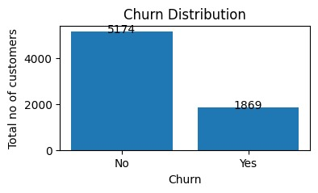

1.3. Gender Distribution:
• This visualization represents the distribution of customers based on gender, categorizing them into:
1. Male customers
2. Female customers
• Each bar corresponds to a gender category.
• The height of the bar indicates the total number of customers belonging to that gender.
• The visualization offers a clear comparison of male and female representation within the telecom customer base.
• Gender distribution helps in understanding overall customer composition.

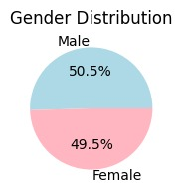
1.4. Contract Distribution:
• This visualization represents the distribution of customers based on the type of contract they have subscribed to.
• The contract types typically include:
1. Month-to-Month contracts
2. One Year contracts
3. Two-Year contracts
• This graph helps in understanding customer commitment levels and service stability.
• The height of the bar indicates the number of customers subscribed to that contract.
• The visualization clearly differentiates between short-term and long-term customer commitments. A large proportion of customers are subscribed to month-to-month contracts, indicating a preference for flexibility.
• Month-to-month contracts are typically associated with higher churn risk.

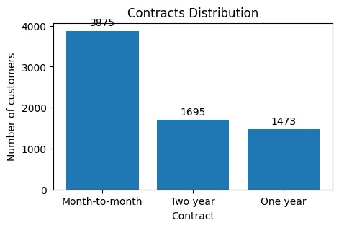
1.5. Partner Distribution:
This visualization represents the distribution of customers based on their partner status, categorizing them into:
• Customers with a partner
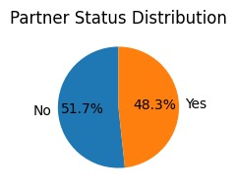
- Customers without a partner The graph helps analyze how relationship status correlates with customer presence in the telecom service.

1.6 Gender Distribution Among Senior Citizens:
• This visualization represents the distribution of senior citizen customers based on gender, categorizing them into:
1. Male senior citizens
2. Female senior citizens
• Each bar corresponds to a gender category among senior citizens.
• The height of the bar indicates the number of senior customers in each gender group.
• The visualization highlights gender-based participation within the senior citizen population.
• Senior male customers often constitute a slightly higher proportion compared to female senior customers.
• Senior citizens, regardless of gender, typically show higher churn sensitivity due to pricing, service complexity, or support needs.
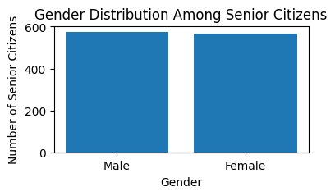

1.7. Senior Citizens:
• This visualization represents the distribution of customers based on senior citizen status, categorizing them into:
1. Senior citizens
2. Non-senior citizens
• Each bar corresponds to a senior citizen category (Yes / No)
• The height of the bar indicates the number of customers in each category.
• The visualization provides a clear demographic split between senior and non-senior customers.
• The majority of customers belong to the non-senior citizen category.
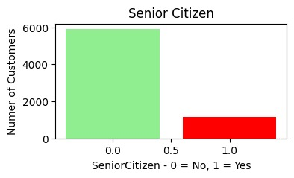

1.8. Payment Method:
• This visualization represents the distribution of customers based on the payment methods they use to pay their telecom bills.
• Common payment methods include:
1. Electronic Check
2. Credit Card (Automatic)
3. Bank Transfer (Automatic)
4. Mailed Check
• This graph helps understand customer payment preferences and billing behavior.
• The height of the bar indicates the number of customers using that payment method.
• A significant number of customers use electronic check, indicating a preference for manual or flexible payment options.
• Customers using automatic payment methods (credit card or bank transfer) generally show more stable behavior.
• Manual payment methods are often associated with higher churn risk.

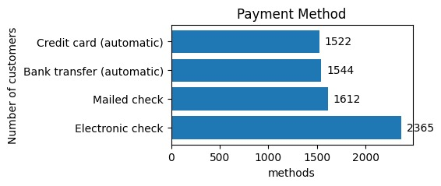

1.9. Churn Possibility Per Sim Distribution:
• This visualization represents the churn possibility across different SIM providers, showing how customer churn varies by SIM type.
• The SIM providers analyzed include:
1. Jio
2. Airtel
3. VI
4. BSNL
• The height of the bar indicates the number or proportion of customers who have churned for that SIM.
• This visualization enables a direct comparison of churn behavior across providers.
• SIM providers with lower churn demonstrate stronger customer retention and service reliability.
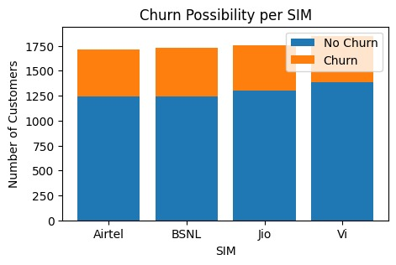

1.10. Share of Sim:
• This visualization represents the distribution of customers based on the SIM provider they are using.
• The SIM providers included in the analysis are:
1. Jio
2. Airtel
3. VI
4. BSNL
• Each bar corresponds to a SIM provider.
• The height of the bar indicates the number of customers using that particular SIM.
• One or two SIM providers dominate the customer base, indicating stronger brand presence and service reach.
• SIM providers with lower customer counts may face competitive challenges such as pricing or network coverage.
• SIM distribution provides a foundational understanding for further churn and performance analysis by provider.
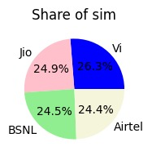

1.11. Sim’s Taken by Year:
• This visualization summarizes the year-wise distribution of SIMs taken by customers
• Each bar represents a specific year.
• The height of the bar indicates the number of SIMs activated in that year.
• The graph provides a clear comparison of SIM adoption over time.
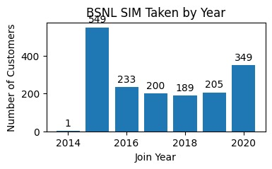
• Years with higher bars indicate strong SIM acquisition, often driven by promotions, competitive pricing, or market expansion
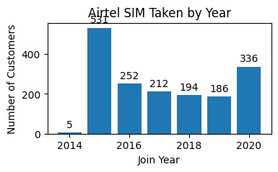

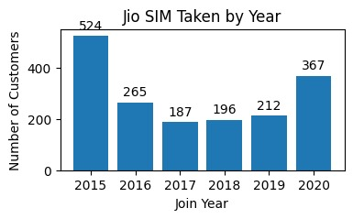
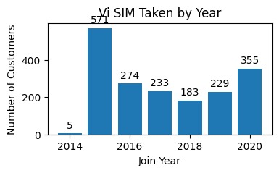
1.12. Sim Services:
• This visualization represents the distribution of customers based on the services subscribed under their SIM connection.
• SIM services typically include:
1. Phone Service
2. Internet Service
3. Streaming Services
• The graph helps understand how customers utilize different services provided through their SIM.
• Each bar corresponds to a specific SIM service category.
• The height of the bar indicates the number of customers subscribed to that service.
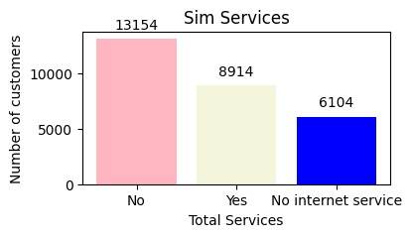
• Customers subscribed to multiple SIM services tend to have higher engagement and lower churn probability.

1.13. Phone Service Distribution:
• This visualization represents the distribution of customers based on whether they have subscribed to the phone service offered by the telecom provider.
• Customers are categorized into:
1. Customers with phone service
2. Customers without phone service
• Each bar corresponds to a phone service category (Yes / No).
• The height of each bar indicates the number of customers in that category.
• The visualization provides a clear view of how widely phone services are used within the customer base.
• The majority of customers have subscribed to phone services, indicating it is a core offering.
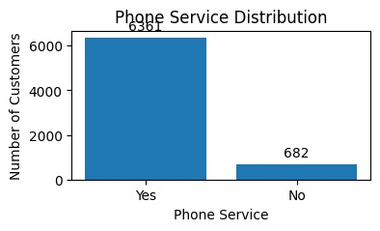
• Lack of phone service may indicate customers who are more likely to churn or switch providers.

1.13. Year-wise Distribution by Customers:
• This visualization summarizes the year-wise distribution of SIMs taken by customers, highlighting overall SIM acquisition trends across different years.
1.Each bar represents a specific year.
2.The height of the bar indicates the number of SIMs activated in that year.
3.The graph provides a clear comparison of SIM adoption over time.
• Recent trends help determine whether SIM adoption is growing, stabilizing, or declining.
• This distribution complements churn and tenure analysis by showing when customers entered the system.
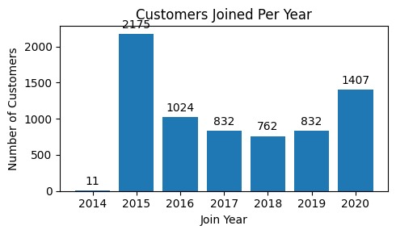
1.14. Average Monthly Charges by Churn:
• This visualization represents the average monthly charges of customers segmented by their churn status:
1. Customers who churned
2. Customers who did not churn
• Each bar corresponds to a churn category (Yes / No).
• The height of the bar indicates the average monthly charge for customers in that category.
• Customers who churned generally have higher average monthly charges compared to
those who stayed.
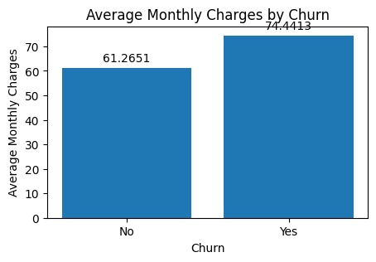
• Customers with lower average monthly charges tend to show better retention.

1.14. Average Tenure by Churn:
• This visualization represents the average customer tenure (in months) segmented by churn status:
1. Customers who churned
2. Customers who did not churn
• Each bar corresponds to a churn category (Yes / No).
• The height of the bar indicates the average tenure of customers in that category.
• The visualization provides a clear comparison of customer longevity between churned and retained users.
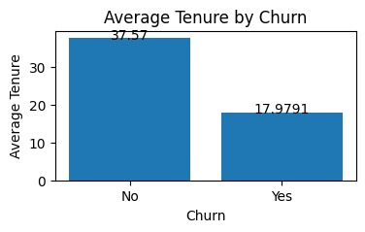
• Customers who did not churn have a significantly higher average tenure.
1.15. : Paperless Billing:
• This visualization represents the distribution of customers based on their paperless billing preference.
• Customers are categorized into:
1. Customers who have enabled paperless billing
2. Customers who have not enabled paperless billing
• Each bar corresponds to a paperless billing category (Yes / No).
• The visualization provides a clear comparison between digital and traditional billing preferences.
• A significant portion of customers have opted for paperless billing, indicating growing acceptance of digital services.
• Customers who use paperless billing often show higher engagement with online platforms.
• Paperless billing users are frequently associated with lower churn risk when combined with auto payment options.

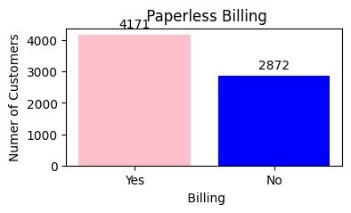
1.16. : Streaming Movies:
• This visualization represents the distribution of customers based on their subscription to the Streaming Movies service.
• Customers are categorized into:
1. Customers who have Streaming Movies service
2. Customers who do not have Streaming Movies service
3. Customers with no internet service, where streaming is not applicable
• This analysis helps understand the adoption level of entertainment-related value-added services.
• Each bar corresponds to a Streaming Movies service category.
• The height of the bar indicates the number of customers in each category.
• The visualization clearly differentiates between streaming subscribers and non-subscribers.
• A substantial number of customers have not subscribed to the Streaming Movies service.
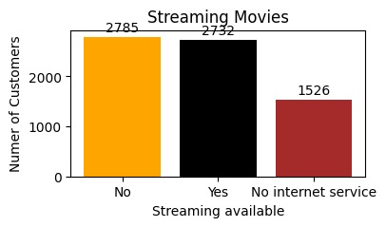
• Customers with internet service are more likely to adopt streaming services.:

1.17.Streaming TV:
• This visualization represents the distribution of customers based on their subscription to the Streaming TV service.
• Customers are categorized into: 1. Customers who have Streaming TV service
2. Customers who do not have Streaming TV service
3. Customers with no internet service, where streaming services are not applicable
• The visualization highlights how widely Streaming TV is adopted among customers.
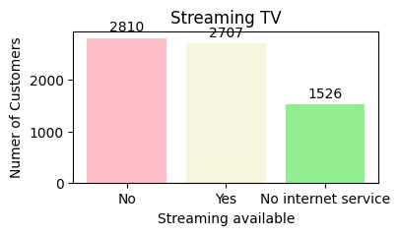
• Streaming TV adoption is higher among customers with reliable internet

services.
1.18. Tenure Distribution:
• This visualization represents the distribution of customers based on their tenure, i.e., the length of time (in months) they have been associated with the telecom service provider.
• Tenure is a key indicator of customer loyalty and service engagement.
• Each bar corresponds to a tenure range (in months).
• The height of the bar indicates the number of customers within that tenure range.
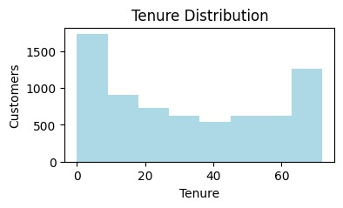
• A large proportion of customers fall within the lower tenure range, indicating many customers are relatively new.
1.19. Customers by Dependents:
• This visualization represents the distribution of customers based on their dependent status, categorizing them into:
1. Customers with dependents
2. Customers without dependents
• Each bar corresponds to a dependent status category (Yes / No).
• The height of the bar indicates the number of customers in each category.
• A larger proportion of customers do not have dependents, indicating a significant segment of individual or single users.
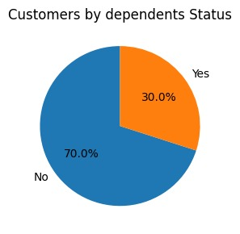
• Customers without dependents tend to be more price-sensitive and flexible, increasing their churn risk.

1.20. Customers by Multiple Lines:
• This visualization represents the distribution of customers based on whether they have multiple phone lines subscribed under their account.
• Customers are categorized into:
1. Customers with multiple lines
2. Customers with a single line
• 3.Customers with no phone service
• This analysis helps understand customer usage patterns and service complexity.
• The height of each bar indicates the number of customers in that category.
• Customers with multiple lines generally show higher engagement and lower churn risk:

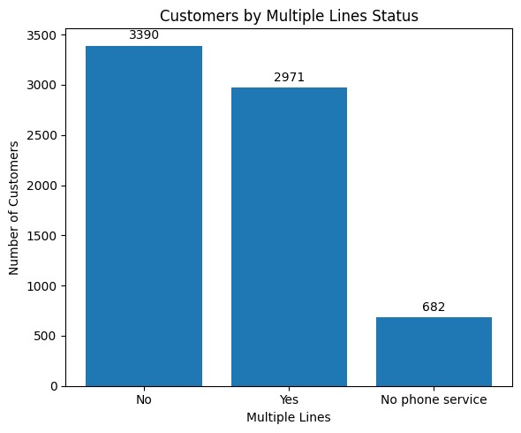
1.21. Total Charges Provided by Sim:
• This visualization represents the distribution of total charges accumulated by customers across different SIM providers.
• The SIM providers analyzed include:
1. Jio
2. Airtel
3. VI
4. BSNL
• SIM providers with a larger customer base or longer average tenure tend to show higher total charges.
• Providers with lower total charges may have higher churn or shorter customer tenure.
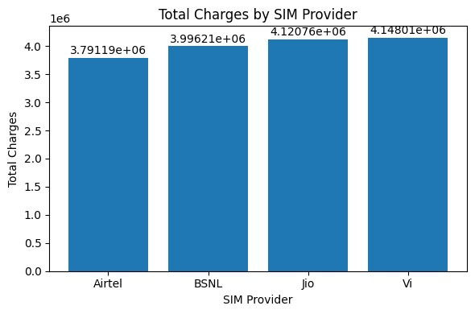
• High total charges indicate strong customer loyalty and long-term engagement.

2. Feature Engineering
- Feature engineering is the process of transforming raw data into meaningful input features that improve a machine learning model’s performance.
- After completing Exploratory Data Analysis (EDA), the dataset was moved to the data preprocessing stage to check data quality and completeness. During this step, most of the features were found to have no direct missing values.
- Next, the dataset was divided into numerical and categorical features so that each type could be processed correctly. While doing this, it was noticed that the Total Charges column, which should be numerical, was stored as text. Because of this, some values appeared as missing.
- To fix this issue, the Total Charges column was converted into a numerical format. During conversion, invalid values were automatically identified as missing.
- Based on the data distribution and model performance, the most suitable method was chosen and applied. This step ensured that the data remained consistent and could be safely used in the machine learning pipeline.
- After completing these steps, the dataset became clean, well-structured, and ready for model training and evaluation.

2.1. Handling Missing Values
- Random Sample Imputation:

- Random Sample Imputation is a method used to treat missing values by filling them with randomly selected observed values from the same feature in the training dataset. This technique ensures that the imputed values come from the existing data distribution.
- One of the key advantages of this approach is that it attempts to preserve the original distribution characteristics of the feature, such as its shape, average value, and spread. For this reason, it is often considered more effective than mean or median imputation, which may oversimplify the data and alter natural patterns.
- However, after applying random sample imputation to the dataset, a noticeable difference was observed in the standard deviation when compared to the original feature. This change indicates that the variability of the data was not accurately maintained. As a result, random sample imputation was not selected as the final method for handling missing values in this dataset.

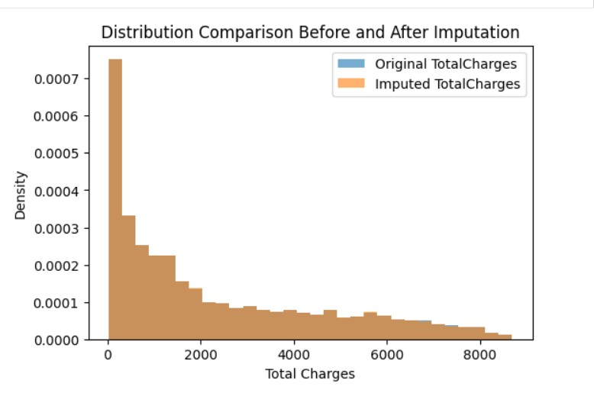

- Constant, Arbitrary, End of Distribution Imputation:
- Constant Imputation is a technique in which missing values are replaced with a predefined fixed value such as 0, −1, or any constant chosen based on domain understanding. This method is simple to apply and helps maintain consistency in the dataset.
- Arbitrary Imputation involves filling missing values using a value that lies outside the usual range of the feature. The selected value does not represent a real observation but acts as a marker to indicate the presence of missing data.
- End of Distribution Imputation handles missing values by assigning extreme values at the boundaries of the data distribution. This is typically done by replacing missing entries with values slightly greater than the maximum or slightly lower than the minimum observed value.

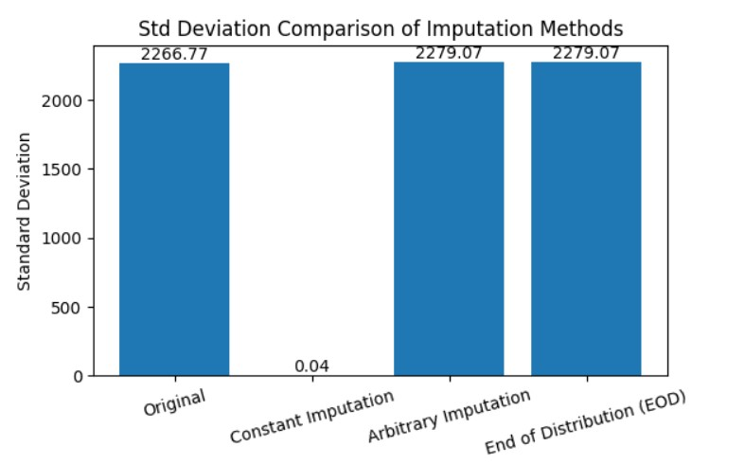

- Drop Missing Data:

- Dropping missing data, also known as data deletion, is one of the most straightforward methods for handling missing values in a dataset. Instead of estimating or replacing missing entries using techniques such as mean, median, or KNN imputation, this approach removes the affected rows or entire columns from the dataset.
- While this method is easy to implement, it may result in the loss of valuable information if a large number of rows or important features are removed. Therefore, it must be applied with caution.
- This technique is most suitable when the proportion of missing values is very small. When missing data accounts for less than 5% of the dataset, dropping those records generally does not cause significant data loss or negatively impact model performance.

- Mean/Median/Mode:

- Mean, median, and mode imputation techniques handle missing values by replacing them with a representative statistical value from the same feature. These methods are commonly used due to their simplicity and ease of implementation.
- In mean imputation, missing entries are filled using the average of the available values in the column.
- In median imputation, missing values are replaced with the central value of the sorted data, making it suitable for skewed distributions.
- In mode imputation, missing values are substituted with the most frequently occurring value in the feature.
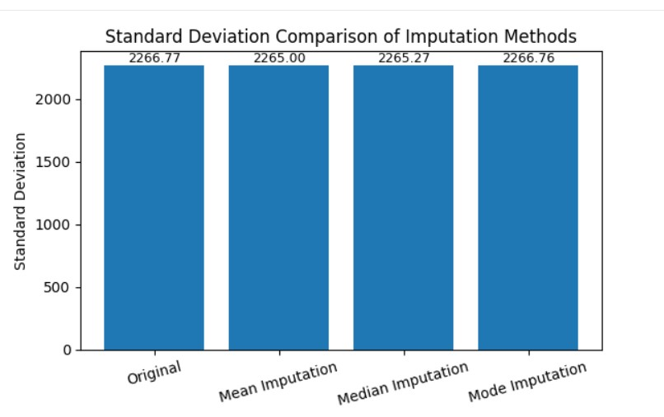
- By applying these imputations there is a much difference in standard deviation compared to the original data.

2.2. Data Seperation:
- In In a churn prediction dataset, the input features usually include both numerical and categorical variables. Before applying preprocessing operations such as scaling, encoding, or missing value treatment, it is important to clearly identify the type of each feature.
- Once missing values were addressed using suitable imputation methods, the dataset was organized into two distinct groups: numerical features and categorical features. This separation is necessary because machine learning models work with numerical data and cannot directly process categorical or text-based inputs.
- Additionally, numerical and categorical features represent information differently and therefore require different preprocessing techniques prior to model training. To achieve this, feature data types were examined, and the pandas select_dtypes() function was used to efficiently extract numerical and categorical columns from the dataset.

2.3. Variable Transformation:
- Variable transformation, also known as feature transformation, is an essential preprocessing step in the machine learning workflow that involves altering feature values to better suit the requirements of statistical and predictive models.
- Many machine learning algorithms, including linear and logistic regression, yield better results when the input data follows a normal or approximately normal distribution. Applying suitable transformations helps reduce skewness and improves data distribution.
- These transformations also minimize the impact of extreme values and outliers, allowing models to learn more stable and consistent patterns. Well-transformed features enhance the overall performance of churn prediction models and support the generation of accurate and interpretable insights for business decision-making. The following section outlines the feature transformation techniques used in this project to improve data quality and model efficiency.

- Log Transformation:
- This transformation involves applying the natural logarithm (ln) to numerical feature values in order to adjust their scale.
- Formula:
- $x^{'}=log⁡(x)$
- Logarithmic transformation reduces positive (right) skewness by compressing higher values more than smaller ones, making the data distribution more balanced. This method can be applied only to features containing positive values.
- This transformer is applicable only to strictly positive values; variables containing zero or negative values will result in a transformation error unless pre-processed beforehand.

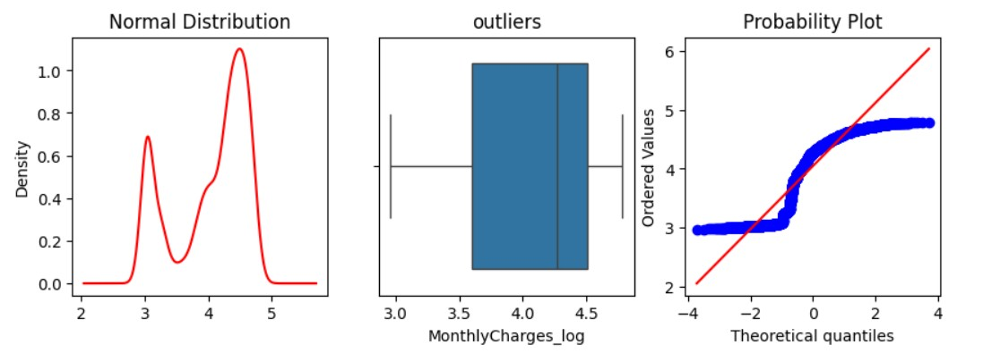

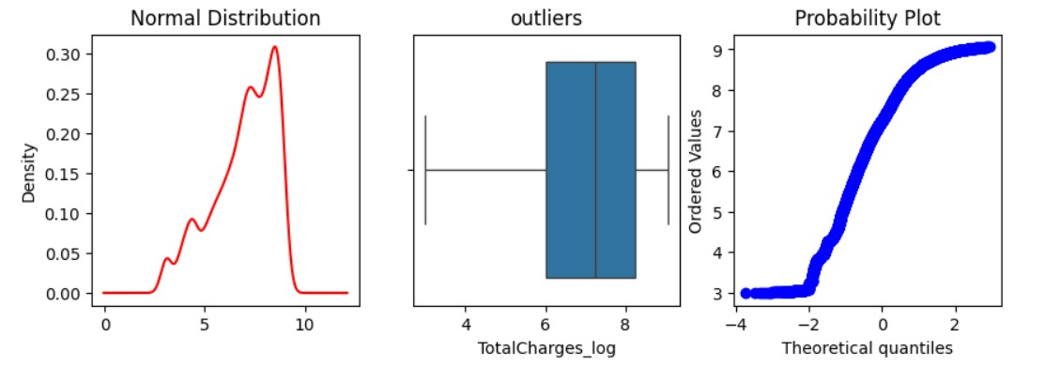

- Box Cox Transformer:
- The Box–Cox transformation is mathematically defined as:
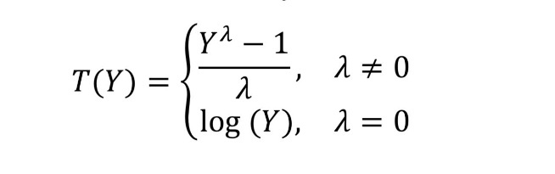
- where $Y$denotes the response variable and $λ$represents the transformation parameter.
- It applies a mathematical formula using a value called lambda (λ) to transform the data. If the value of λ is zero, the transformation uses a logarithm; otherwise, it uses a power-based formula.
- The best value of λ is automatically selected by testing different values (usually between −5 and +5) and choosing the one that makes the data more normally distributed. This transformation can only be applied to positive values, as it does not work with zero or negative numbers.
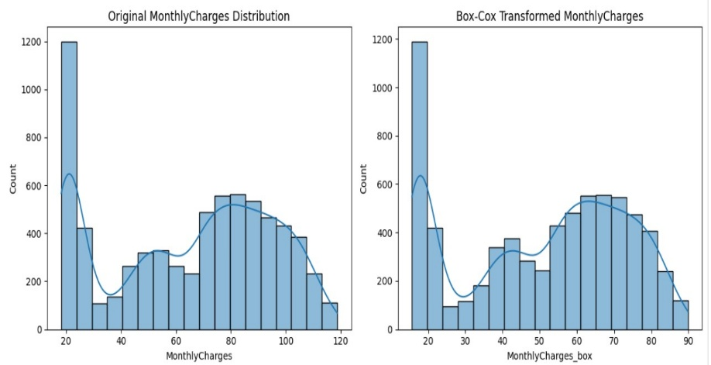
- In this project, after applying the Box–Cox transformation, the data distributions did not improve significantly. The graphs used to check normality also showed that the transformed data still did not closely follow a bell-shaped curve.Therefore, since the transformation did not provide meaningful

- Square Root Transformation:

- This transformation involves taking the square root of numerical values to make the data distribution more balanced.
- Formula:
- $x^{'}=\sqrt{x}$
- Explanation:
The square root transformation helps reduce moderate positive skewness and brings stability to the variance by compressing larger values more than smaller ones.
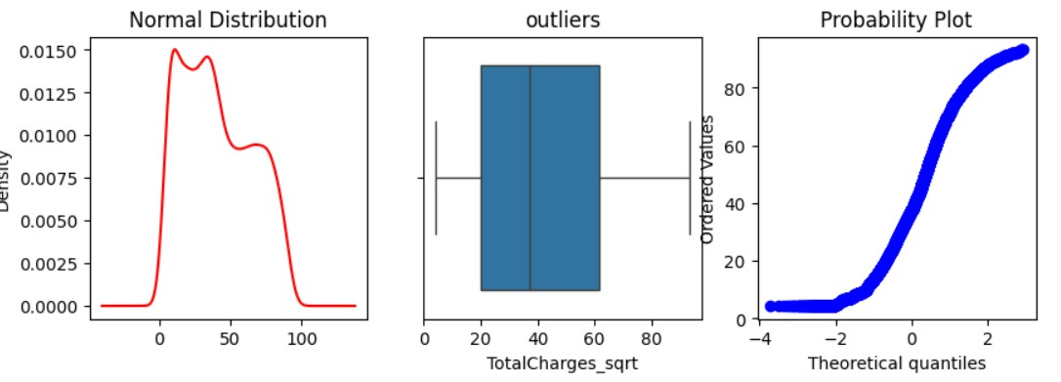
- It is commonly applied to features that contain only positive values and show a moderate level of skewness.

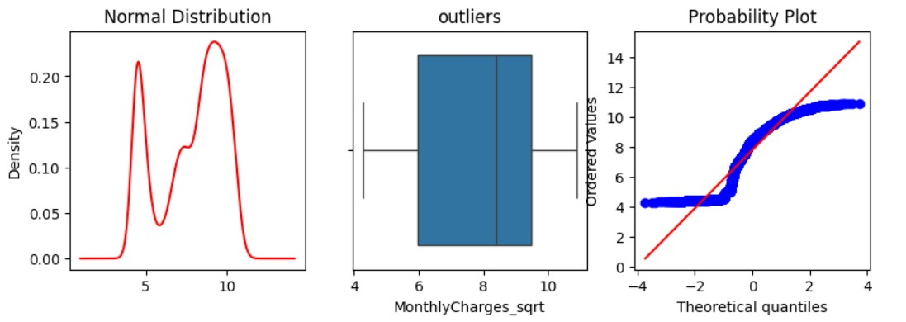

- Yeo–Johnson Transformation (Best Approach):

- The Yeo–Johnson transformation is a power-based, parametric feature transformation technique used to reduce skewness and improve the normality of numerical features. It is an extension of the Box–Cox transformation and is specifically designed to handle both positive and negative values, making it more flexible for real-world datasets.
- Unlike Box–Cox, which requires strictly positive inputs, Yeo–Johnson can be applied to datasets containing zero or negative values without requiring any data shifting. The transformation uses a parameter 𝜆(lambda) to determine the strength and form of the transformation, which is automatically estimated from the data using maximum likelihood estimation.
- Mathematical Formulation: For a feature value 𝑥, the Yeo–Johnson transformation is defined as:
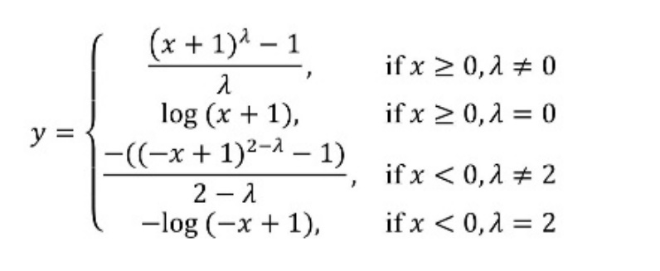
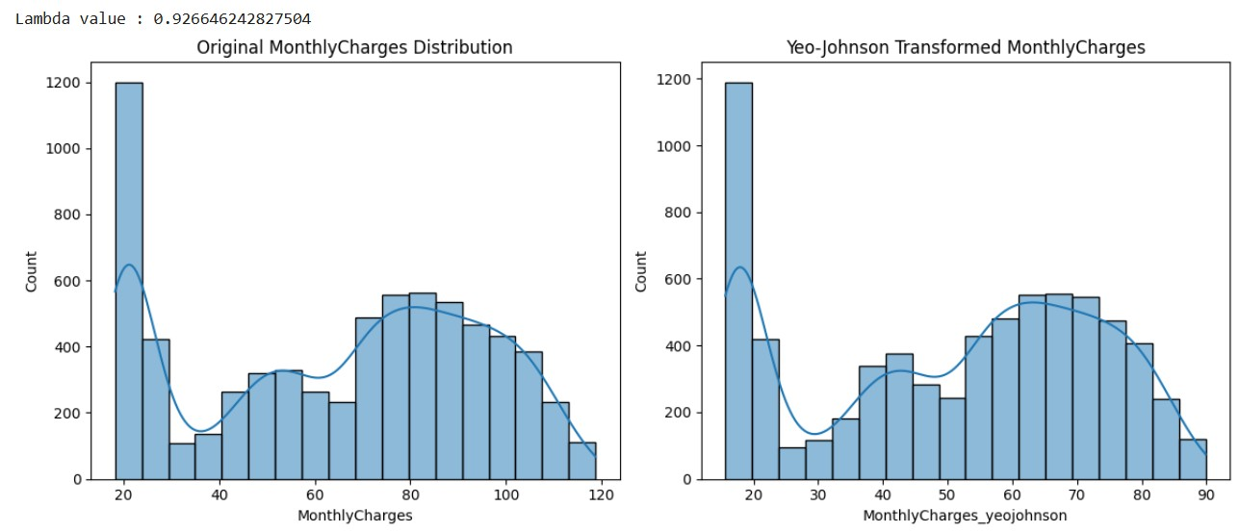

- Exponential Transformation
- This transformation uses the exponential function to modify numerical feature values.
- Formula:
- $x^{'}=exp⁡(x)$
- The exponential transformation expands smaller values and further increases the spacing between larger values, effectively altering the distribution shape.
- It is infrequently applied and is mainly used in cases where a feature shows negative skewness and needs correction.

2.4 Handling Outliers:
- Managing outliers is an important preprocessing step that helps maintain data quality and enhances the stability and reliability of machine learning models. Once the data was transformed to achieve distributions closer to normality, the dataset was examined for extreme values. Box plot visualizations revealed that several numerical features contained unusually high or low values that differed significantly from the majority of observations.
- These extreme data points can distort feature distributions, increase variance, and adversely affect model training, especially for algorithms that are sensitive to scale and data distribution. To address these issues and improve model robustness, various outlier handling methods were applied, including Arbitrary Outlier Capping and logarithmic transformations.
- By limiting the impact of extreme values while retaining the overall structure of the data, these techniques contributed to more consistent learning behavior and improved the reliability of churn prediction results.
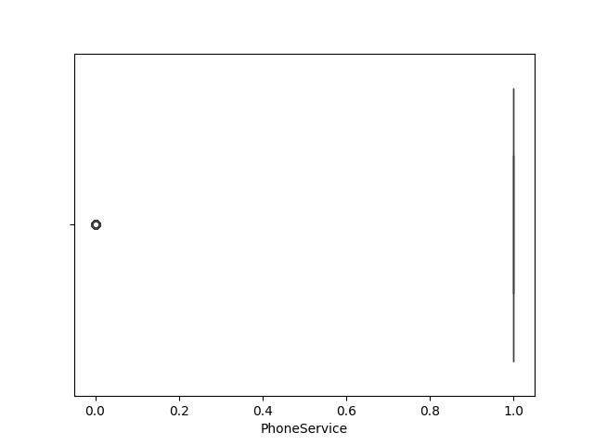
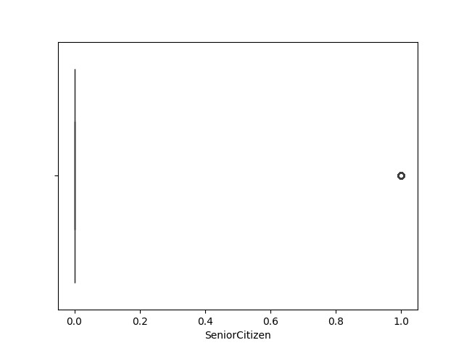

- Capping:
- Outlier capping is a technique used to manage extreme values in numerical features that may negatively impact model training, stability, and prediction accuracy. Rather than eliminating outlier observations, this method limits their effect by setting them to predefined minimum and maximum threshold values, ensuring that all data points are retained.
- Any values falling below the lower threshold are replaced with the minimum cap, while values exceeding the upper threshold are set to the maximum cap. Although this technique is straightforward to apply, it is not based on the underlying data distribution and depends largely on manually defined threshold limits.
- If these thresholds are not carefully selected, the approach may either excessively restrict or insufficiently control extreme values, resulting in information loss or altered feature distributions. Due to these drawbacks and the possibility of introducing bias, outlier capping was not included in the final preprocessing and model development pipeline.

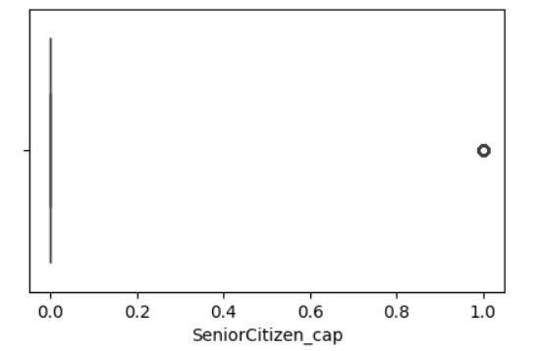

- Trimming (Best Approach):
• Outlier trimming is a technique used to manage extreme values by completely removing data records when feature values fall outside defined statistical boundaries. A widely used trimming method is the Interquartile Range (IQR) approach, where observations lying beyond the interval $\left[Q1-1.5×IQR, Q3+1.5×IQR\right]$are excluded from the dataset.

• Another commonly applied method is the Z-score technique, in which data points are removed if their standardized value exceeds a predefined threshold, typically based on the condition $∣Z∣>\text{threshold}$.

• Although trimming can effectively reduce the impact of extreme values, it removes entire observations from the dataset. This can result in the loss of rare yet valid data points, which are especially important in churn analysis where unusual customer behavior may carry significant insights. Excessive trimming may also reduce dataset size and introduce bias, ultimately affecting the model’s ability to generalize well.

• Due to these drawbacks and the potential risk of discarding valuable information, the outlier trimming approach was not included in the final preprocessing and model development pipeline.

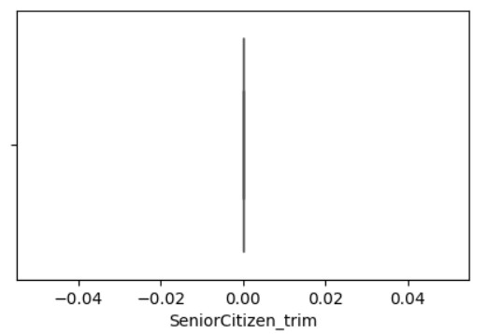

- 5th and 95th Quantile:
The 5th–95th quantile technique is a percentile-based approach used for handling outliers during the data preprocessing phase of a machine learning workflow. Rather than discarding extreme observations, this method limits their effect by capping values at statistically defined percentile thresholds, ensuring that all data records are retained.
In this approach:
- The 5th percentile (P5) denotes the value below which 5% of the observations fall.
- The 95th percentile (P95) denotes the value below which 95% of the observations fall.
Mathematically, these thresholds are defined as:
$$P5=\text{Quantile}(X,0.05) \\ P95=\text{Quantile}(X,0.95)$$
By replacing values below P5 and above P95 with these respective bounds, the method reduces the impact of extreme values while preserving the overall structure and distribution of the dataset.

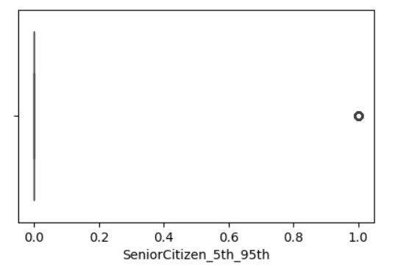

2.5 Categorical Encoding:
- Categorical encoding is the process of transforming categorical attributes into numerical values, as machine learning algorithms require numerical inputs for computation. Following feature engineering, this step is applied before proceeding with feature selection and model development.
- The dataset includes several categorical features related to customer demographics, service subscriptions, and payment details, all of which must be converted into an appropriate numerical format. Each categorical feature is examined based on its number of distinct categories in order to determine the most appropriate encoding technique.
1. One Hot Encoding:
- One-Hot Encoding is used for categorical variables that contain more than two distinct values, commonly referred to as multi-class nominal features. In this approach, each unique category is transformed into a separate binary feature, where a value of 1 denotes the presence of that category and a value of 0 represents its absence.
- Since each observation can belong to only one category at a time, exactly one dummy variable is set to 1 per row, which is why the method is referred to as “one-hot” encoding.

2. Ordinal Encoding:
- Ordinal Encoding transforms each category into a numerical value that represents its relative position, thereby maintaining the inherent ordering among the categories.
- This encoding technique is suitable when a categorical variable has a well-defined logical order and when the relative ranking between categories provides valuable information for model learning.
- Typical examples of ordinal data include education levels:
- (High School < Bachelor < Master < PhD)
- satisfaction ratings (Poor < Average < Good < Excellent)
- size categories (Small < Medium < Large)
- Since the ordering of contract types contains important information related to customer behavior, Ordinal Encoding was applied to the Contract feature to ensure that the model accurately captures and utilizes this hierarchical relationship.
3. Label Encoding:
- Label Encoding is a method used to transform categorical or textual values into numerical form by assigning a unique integer to each distinct category. In customer churn prediction tasks, this technique is primarily applied to the target (dependent) variable when it is categorical, allowing machine learning models to interpret class labels correctly.
- However, Label Encoding is not suitable for nominal input features, as it does not maintain any natural ordering and may unintentionally impose an artificial rank among categories. For instance, in the case of a binary target variable, categories such as Male and Female may be encoded as 0 and 1 respectively, but only when the variable serves as the output label.
- For nominal input features that do not have an inherent order, One-Hot Encoding is generally preferred, as it prevents the model from learning misleading ordinal relationships.
3. FEATURE SELECTION:
3.1. Filter Methods:
- Filter methods are one of the most commonly used feature selection techniques in machine learning.
- These methods select features based on statistical properties of the data without involving any machine learning model.
- Filter methods help in removing irrelevant, redundant, or non-informative features before model training, thereby reducing dimensionality and improving model performance.
- In this project, variance-based filter techniques were used to identify and remove uninformative numerical features.
- In this project, the following two filter-based techniques were applied:
i. Constant Technique:
- The Constant Feature Technique removes features that have zero variance across all observations.
- If a column contains the same value for every record, it does not provide any useful information to the model.
- Variance Threshold with a threshold value of 0.0 was applied to identify and remove such constant features.
- Removing constant features helps reduce noise and unnecessary computations during model training.

ii. Quasi Constant Technique:
- The Quasi-Constant Feature Technique removes features that have very low variance, meaning one value dominates most of the observations.
- Variance Threshold with a threshold value of 0.1 was applied to detect quasi-constant features.
- Such features contribute very little to model prediction and may negatively impact generalization.
- Eliminating quasi-constant features improves model robustness and stability.
𝑥𝑖represents each individual data point
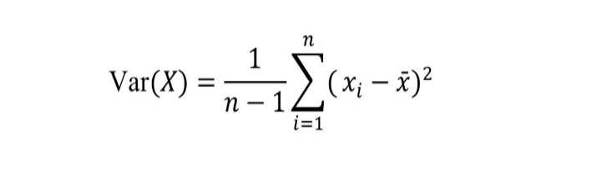
- X𝑖 represents each individual data point,
- 𝑥ˉdenotes the mean of the data, and
- n is the total number of observations.
3.2. Hypothesis Testing:
- Hypothesis testing is a statistical approach used to examine whether a meaningful relationship exists between input features and the target variable. It plays an important role in identifying features that have a significant influence on customer churn.
- Several hypothesis testing methods can be applied for this purpose, including Z-test, T-test, ANOVA, Chi-square test, and correlation analysis.
- In machine learning, hypothesis testing techniques help determine whether observed patterns are statistically meaningful or occurred by chance.

4. MERGING
- During the preprocessing phase, the dataset was divided into numerical and categorical features so that suitable techniques such as scaling, encoding, and feature selection could be applied to each type independently.
- After completing all required transformations and evaluating the importance of both feature groups, they were recombined for model development.
- The processed numerical and categorical features were merged using the pandas.concat() function.
- This merging was carried out separately for the training and testing datasets to prevent data leakage. The resulting unified dataset provides the model with a complete and well-structured set of features, enabling accurate learning and reliable evaluation.

5. DATA BALANCING
- During the preprocessing phase, the dataset was divided into numerical and categorical features so that suitable techniques such as scaling, encoding, and feature selection could be applied to each type independently.
- In practical machine learning applications, the target variable frequently suffers from class imbalance, where one class has a much higher number of observations compared to the other class(es).
- This imbalance can lead models to favour the majority class, causing poor predictive performance for the minority class, which is often the most important in customer churn analysis.
- To overcome this challenge, various data balancing strategies such as under sampling, oversampling, and SMOTE (Synthetic Minority Over-sampling Technique) can be employed. In this project, SMOTE was chosen because it is an advanced oversampling approach that creates new synthetic samples instead of simply replicating existing minority class instances.
- The SMOTE algorithm works by identifying the k nearest neighbours (commonly k = 5) for each minority class data point. One or more of these neighbours are then randomly selected, and new synthetic observations are generated along the line joining the original sample and the selected neighbour. This process produces realistic and diverse minority class samples.
- The synthetic data point is created using the following formula:
$$x_{\text{new}}=x_{i}+(x_{zi}-x_{i})×δ$$
where:
- $x_{i}$represents an original minority class instance
- $x_{zi}$denotes one of the k nearest neighbors of $x_{i}$from the minority class
- $δ$is a random value between 0 and 1
- By generating realistic synthetic data, SMOTE helps balance the class distribution and enhances the model’s ability to learn meaningful patterns, ultimately improving generalization and churn prediction performance.

6. FEATURE SCALING:
- Feature scaling is a data preprocessing method used to transform numerical features so that they lie within a similar range prior to model training. Many machine learning algorithms, particularly those based on distance calculations or gradient optimization, achieve better performance and faster convergence when input features are scaled consistently.
- In this project, Standard Scaling, also known as Z-score normalization, was applied to the numerical features during model development.
- This technique transforms each feature value using the following formula:

$$z=\frac{x-μ}{σ}$$
where:
- $μ$represents the mean of the feature
- $σ$denotes the standard deviation of the feature
- $z$is the standardized value
- This transformation centers the data around zero with a unit standard deviation, allowing features to contribute equally to the learning process.

7. MODEL TRAINING
- After completing all the data preparation steps such as feature engineering, feature selection, class balancing, and feature scaling, the dataset was ready to be used for training the model.
- Since the output variable has only two possible outcomes, the problem was treated as a binary classification task.
- Multiple classification models were trained using the same training data so that their performance could be compared fairly.
- The best model was chosen based on evaluation results, with special focus on the ROC curve and AUC score.

ROC Curve (Receiver Operating Characteristic):
• ROC curve is a visual tool used to evaluate the performance of a classification model at various decision threshold levels.
- It plots the relationship between the True Positive Rate (TPR), also referred to as recall or sensitivity, and the False Positive Rate (FPR), which is defined as one minus specificity.
The True Positive Rate is calculated as:
$$TPR=\frac{TP}{TP+FN}$$
The False Positive Rate is calculated as:
$$FPR=\frac{FP}{FP+TN}$$
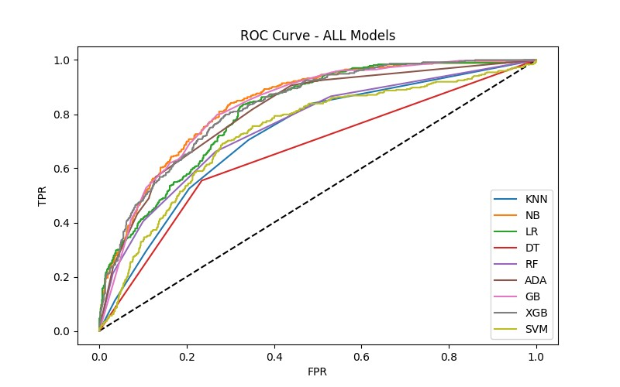
By illustrating the trade-off between sensitivity and specificity, the ROC curve helps assess how effectively a model distinguishes between the two classes as the classification threshold is adjusted.

AUC (Area Under the ROC Curve):
- AUC is a single numerical measure that captures the overall performance of a classification model. It reflects how well the model can separate positive and negative classes.
- A higher AUC value indicates stronger discriminative capability between churned and non-churned customers.
- AUC = 1.0 indicates a perfect classifier
- AUC = 0.5 indicates no better performance than random guessing
Model Selection Criterion:
- AUC is a single numerical measure that captures the overall performance of a classification model. It reflects how well the model can separate positive and negative classes.
- Among all trained models, the algorithm with the highest ROC–AUC score and stable performance across thresholds was selected as the final model.
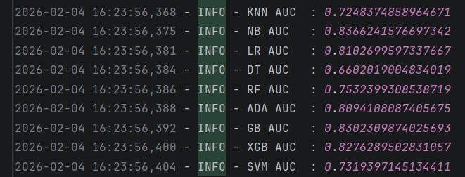
- ROC–AUC was preferred as the primary evaluation metric because it is robust to class imbalance and threshold-independent.

- Based on the evaluation results, the Naive Bayes (NB) classifier achieved the highest AUC score (≈ 0.8366) among all tested models. The ROC curve for Naive Bayes consistently remained above those of the other algorithms, indicating superior class separability and more reliable discrimination capability.

8.BEST MODEL
- Multiple classification algorithms were trained and evaluated using accuracy and ROC-AUC metrics.
- Among all trained models, Naive Bayes achieved the highest ROC-AUC score of 0.8366, making it the best-performing model.
- The final model was evaluated on the test dataset using accuracy, ROC curve, and ROC-AUC score.
- The output is a class label such as Yes or No, where Yes refers to 1 and No refers to 0, along with the corresponding probability estimates.
- Once the evaluation is completed and the model performance is satisfactory, the best trained Naive Bayes model is saved using pickle for future use and deployment.

8. HYPERPARAMETER TUNING
- Hyperparameter tuning is the process of identifying the optimal combination of hyperparameters that maximizes a machine learning model’s performance. Once the algorithm for model development is finalized, tuning is performed to enhance model accuracy and generalization ability.
- The selection of optimal hyperparameters can be achieved using techniques such as Grid Search CV and Randomized Search CV. Grid Search CV exhaustively evaluates all possible combinations of the specified hyperparameter values using cross-validation, ensuring a thorough search of the parameter space. In contrast, Randomized Search CV samples a fixed number of random parameter combinations, making it computationally more efficient for large search spaces.
- In this project, Grid Search CV was employed to determine the best hyperparameter configuration. Grid Search CV (Grid Search with Cross-Validation) is an automated approach that systematically explores a predefined grid of hyperparameters, trains models for each combination, evaluates their performance using cross-validation, and finally returns the optimal set of hyperparameters along with the best-performing model.

8. FRONT-END & BACK-END
The system uses a Flask-based web application with an HTML frontend that allows users to input customer details through an interactive form. The form collects numerical features such as tenure and charges, along with categorical attributes like contract type, payment method, and service options using dropdowns to ensure valid inputs. On submission, the data is sent to the backend via an HTTP POST request, and the prediction result with probability is displayed on the same page in real time.
The backend, developed using Flask, loads the trained Naive Bayes model, scaler, and encoding mappings at startup. It preprocesses incoming data using the same transformations applied during training, including scaling and categorical encoding, while maintaining feature alignment. The processed data is passed to the model to generate churn prediction and probability, which are then returned to the frontend, enabling seamless and efficient real-time predictions.

9. RESULT
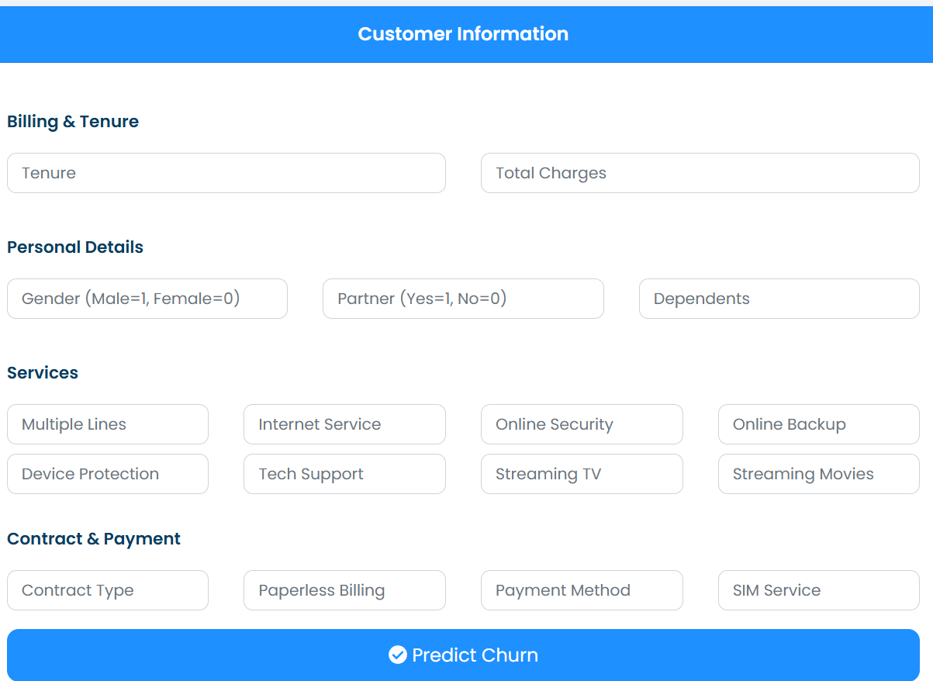

CONCLUSION:
The Customer Churn Prediction project demonstrates the effective application of machine learning techniques to help telecom companies proactively identify customers who are at risk of discontinuing their services. By analysing key customer attributes such as demographics, service usage patterns, contract type, and billing information, the model uncovers meaningful insights into customer behaviour and churn drivers. The dataset was thoroughly pre-processed using industry-standard techniques, including data cleaning, feature engineering, feature selection, class balancing, and feature scaling, ensuring high-quality inputs for model training. Multiple machine learning algorithms were trained and evaluated to identify the most suitable model for churn prediction. Model performance was assessed using ROC and AUC metrics, which are robust indicators for binary classification problems. Based on this evaluation, Logistic Regression was selected as the final model, achieving an overall prediction accuracy of 75% while maintaining reliable class separability between churned and non-churned customers. To enhance real-world usability, the project also includes a Flask-based web application, allowing users to input customer details and instantly receive churn predictions. This end-to-end deployment bridges the gap between data science and business operations, enabling data-driven decision-making and supporting proactive customer retention strategies. Overall, this project highlights how machine learning, when combined with thoughtful preprocessing and deployment, can serve as a powerful tool for improving customer retention and business performance.

FUTURE ENHANCEMENT:
• Integration of Deep Learning Models: Incorporate advanced deep learning architectures such as Artificial Neural Networks (ANN), Convolutional Neural Networks (CNN), and Long Short-Term Memory (LSTM) networks to capture complex nonlinear and sequential patterns in customer behaviour, potentially improving prediction accuracy.
• Real-Time Churn Monitoring: Implement real-time data pipelines using streaming technologies to enable continuous churn prediction and timely identification of at-risk customers.
• Advanced Visual Analytics Dashboard: Develop an interactive visual analytics dashboard to monitor churn trends, customer segments, and risk scores over time, supporting strategic business decision-making.
• Scalable Deployment Architecture: Enhance the system with scalable deployment solutions to support large-scale telecom datasets and high-frequency prediction requests. These enhancements would further strengthen the system’s predictive power, scalability, and business impact.

REFERENCES:
- https://www.kaggle.com/datasets/blastchar/telco-customer-churn
- https://feature-engine.trainindata.com/en/latest/api_doc/index.html
- https://scikit-learn.org/stable/index.html
- https://scikit-learn.org/stable/modules/model_evaluation.html#roc-metrics
- https://pandas.pydata.org/docs/
- https://numpy.org/doc/
- https://flask.palletsprojects.com/en/latest/

